Spring Bay Area Yeast Meeting
April 19th, 2014
M106, Alway Building, Stanford Medical Center – Stanford University

9:00 Coffee and Registration (Courtyard outside M106)
10:00 – 12:00 Research Talks M106, Alway Building
FRET-based assay for monitoring septin filament assembly
Elizabeth “Libby” Booth, Jeremy Thorner Lab, UC Berkeley

Yeast’s evil relative: a fungus that swims, crawls, and kills vertebrates
Tim Stearns, Stanford University

Number of Cln3 molecules determines budding probability in yeast
Kurt Schmoller , J.M. Skotheim Lab, Stanford University

Re-replication of a centromere induces whole-chromosomal instability and aneuploidy
Stacey Hanlon, Joachim J. Li Lab, UCSF

Heterozygote advantage in adapting diploids
Diamantis Sellis, Dmitri Petrov Lab, Stanford University

TBA
Chandra Richter - Galo Research

12:00 – 1:45 Lunch and Posters (Courtyard outside M106)

1:50 – 3:45 Research Talks M106, Alway Building

Investigating the functional defects of human p53 mutations in a yeast model system: an introductory molecular biology laboratory course for undergraduates
Daria Hekmat-Scafe, Martha Cyert and Tim Stearns Lab, Stanford University

Chomatin Remodeling as a Molecular Basis of Expression Noise
Christopher Brown, Hinrich Boeger Lab, UC Santa Cruz

Insights into yeast gene regulation though high-throughput and precision RNA boundary mapping
Aino Järvelin, Lars Steinmetz Lab, EMBL

Transient expression of intrinsically disordered proteins heritably transforms the phenotypic landscape of S. cerevisiae
Daniel Jarosz, Stanford University

Accounting for biases in riboprofiling data indicates a major role for proline in stalling translation
Carlo Artieri, Hunter B. Fraser Lab, Stanford University

The role of nucleoporins specifically Nup2 during meiosis in budding yeast
Daniel Chu, Sean Burgess Lab, UC Davis

3:50 – 4:50 Key Note Speaker M106

“TBA”

Randy Schekman

Howard Hughes Investigator and Professor of Cell and Developmental Biology,
UC Berkeley
Nobel Prize in Physiology or Medicine, 2013

4:50 – 5:30 Wine reception (Courtyard outside M106)

Wine generously donated by:
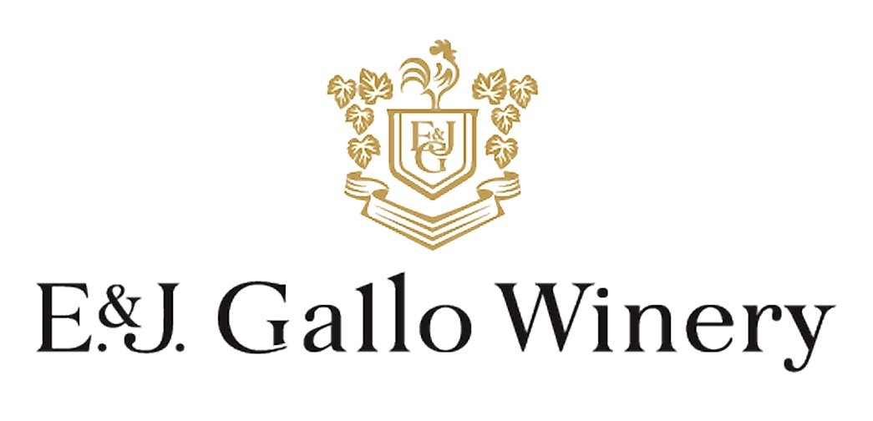
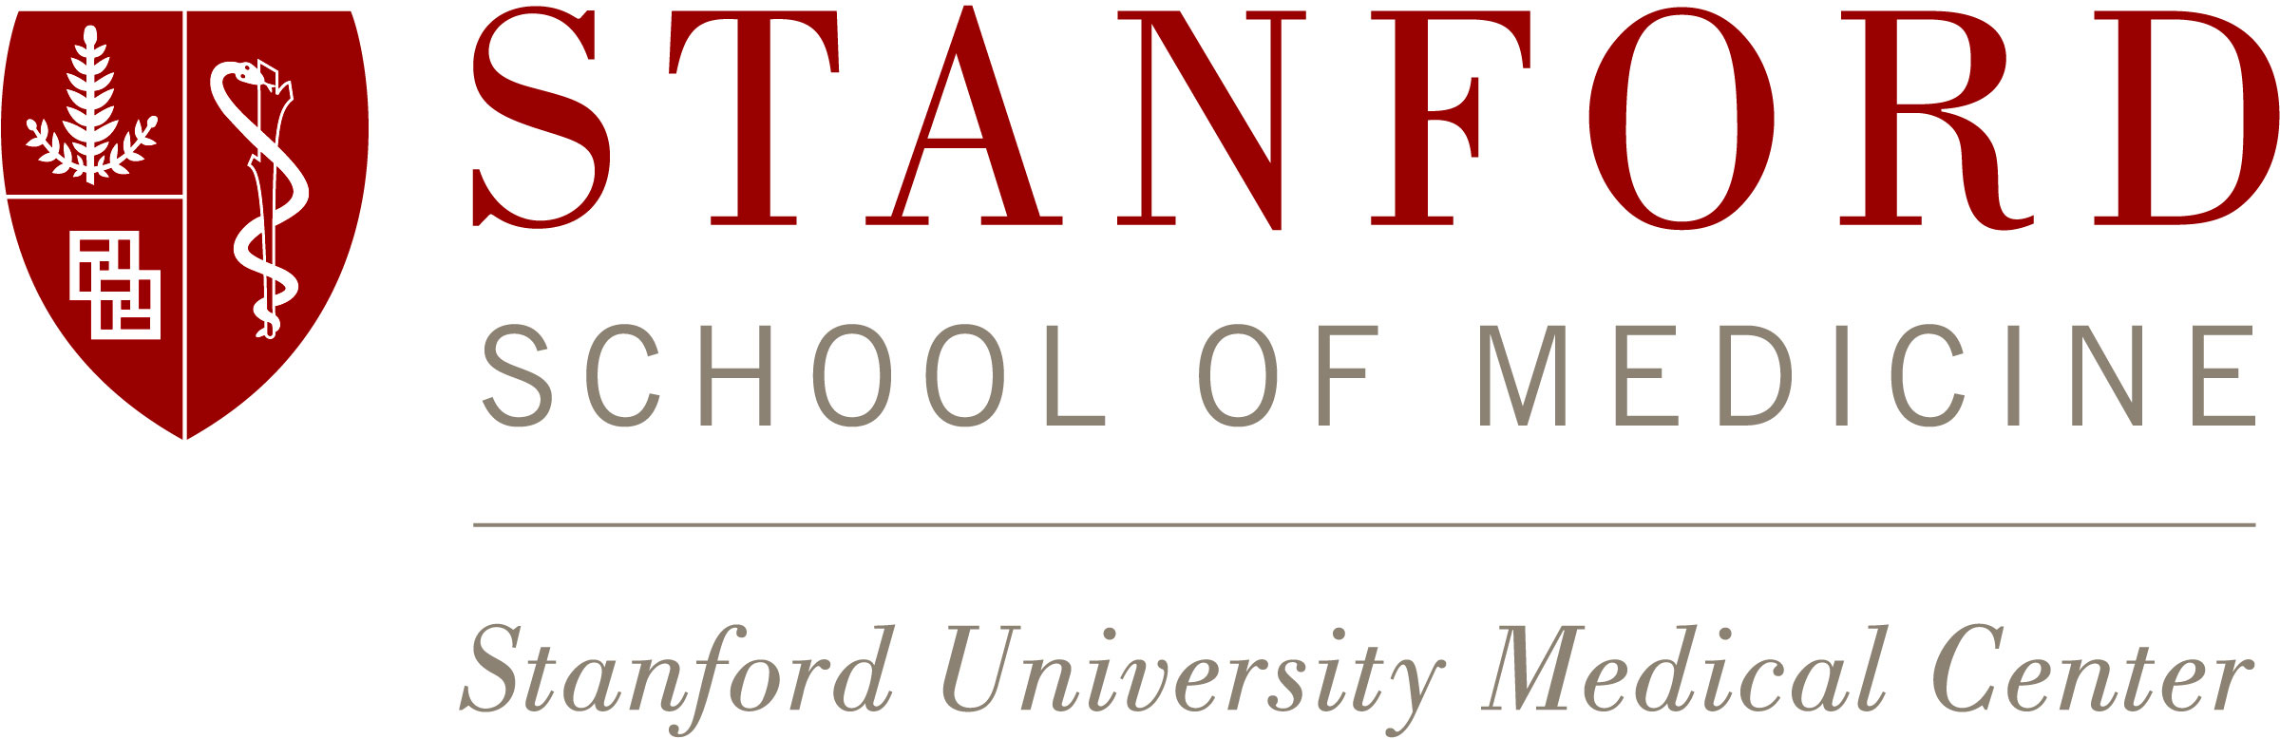
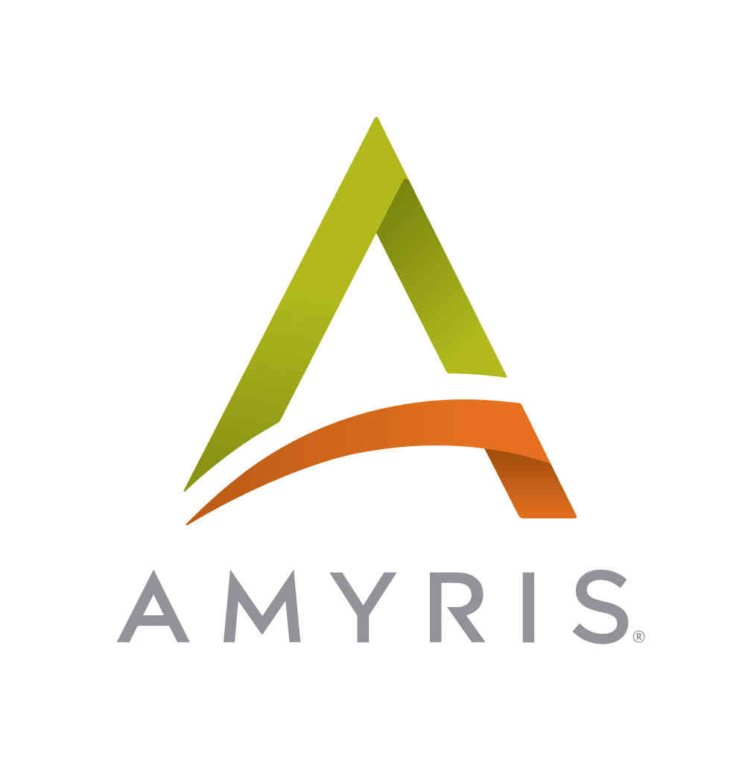
A special thank you to The Bay Area Yeast Meeting Sponsors:

